SCHEDA 1
IL DISCO DI FESTO

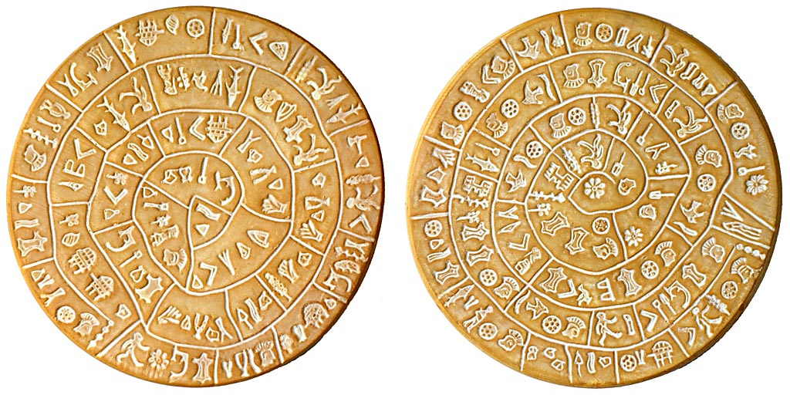

https://upload.wikimedia.org/wikipedia/commons/3/3d/PhaistosDiskLarge.jpg

